Practical training to drive a motorcycle

Training content
- Protective equipment and mechanical check
- Controls, driving position and starting
- Vision and gaze direction
- Moving and handling a motorcycle
- Setting in motion, balance and immobilization
- Gear change, downshift
- Taking a turn
- Parking
- Emergency braking in a straight line
- Obstacle avoidance
Each module should have an introduction on key concepts, feedback from the trainer on the practice and a summary conclusion with key messages.
An evaluation form to be completed during the training by the student and the trainer is available at the end of this document. The form must be signed by the trainer and the student. It attests to the completion of the training and the student's ability to operate a motorcycle in the context of his/her activities.
1. PROTECTIVE EQUIPMENT AND MECHANICAL CHECK
Objectives
- Check the condition of protective equipment.
- Check the condition of the main mechanical components of a motorcycle.
- Understand the importance of protective equipment and the importance of the mechanical check of a motorcycle for safety.

Implementation

Protective equipment
- Demonstrate (by you or a student)
- Check the pieces of protective equipment, emphasizing the role they play in safety, their usefulness, size and fit, signs of wear.

Mechanical check
- Demonstrate (by you or by a student)
- Conduct the check by explaining what to check, how to check it, and why it is important to check it.
- Conduct a guided practice session
- Assist students as they conduct the check and provide feedback on how they are conducting the check.

2. CONTROLS, DRIVING POSITION AND STARTING

Objectives
- Locate and become familiar with the controls.
- Adopt a safe riding position.
- Get on and off the motorcycle.
- Start and stop motorcycle engine when cold and hot

Implementation

Controls

Demonstrate (by you or by a student)

Introduce the motorcycle controls, emphasizing their role and how they should be used.

Conduct a guided practice session

Have the students present the controls to you and correct them if necessary.

Getting on the motorcycle

Demonstrate (by you or by a student)

Do the exercise (sit on the bike) and explain the steps you are doing at the same time.

Conduct a guided practice session

Assist students as they get on the bike and provide feedback on their riding position.

Starting the engine
- If relevant, introduce starting with engine compression.
- Demonstrate (by you or by a student)
- Start the motorcycle and explain the starting steps.
- Conduct a guided practice session
- Assist students and provide feedback on starting.

3. VISION AND GAZE DIRECTION

Objectives
- Direct your gaze to the right place.
- Adjusting mirrors properly.
- Systematically perform the necessary visual checks before putting a motorbike into motion.

Implementation
- Demonstrate (by you or by a student)
- Introduce the proper position of the mirrors, situations requiring a visual check while riding, the proper technique for performing an effective check (body position, maintaining speed, etc.). To demonstrate to students the influence of eye contact on driving, you can, for example, direct your gaze to the ground while attempting to make a turn.
- Conduct a guided practice session
- Assist students and provide feedback on their visual checks.
- Form teams of two
- Invite one of the two apprentices to ride a motorcycle.
- Have the other learner move slowly to the sides and back of the motorcycle so that the learner on the motorcycle can actually see the blind spot areas.

4. MOVING AND HANDLING A MOTORCYCLE

Objectives

Move the motorcycle without using the engine.

Raise the motorcycle

Implementation
Moving a motorcycle without the help of the engine
- Demonstrate (by you or by a student)
- Do the exercise and explain the different steps at the same time.
- Conduct a guided practice session
- Assist and provide feedback to students.
- Conduct a stand-alone practice session
- Let students do the exercise and observe them so that you can assess their learning afterwards.

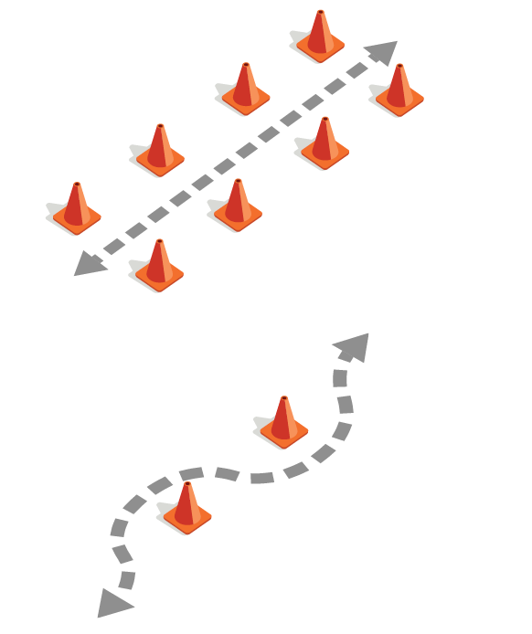

5. SETTING IN MOTION, BALANCE AND IMMOBILIZATION

Objectives
- Set a motorcycle in motion.
- Keep a motorcycle running at very low speed in balance.
- Use the front and rear brakes to stop a motorcycle at a given location at very low speed.

Implementation
- Demonstrate (by you or by a student)
- Do the exercise and explain the different steps at the same time.
- Form teams of two
  - One member of each team rides a motorcycle.
  - The other student pushes the bike around the course.
  - The student who is driving must stop the bike at a specific point at the end of the course.
  - Students switch roles after each run through the course.
- Conduct a guided practice session
- Have each student take turns riding the course as slowly as possible and then stop as precisely as possible.
- Assist and provide feedback to students.
- Conduct a stand-alone practice session
- Let students do the exercise and observe them so that their learning can be assessed later.

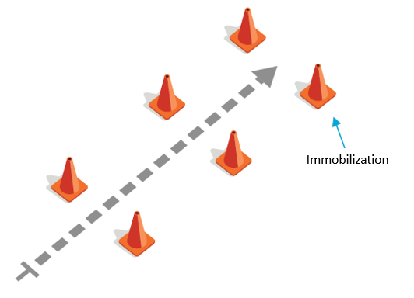
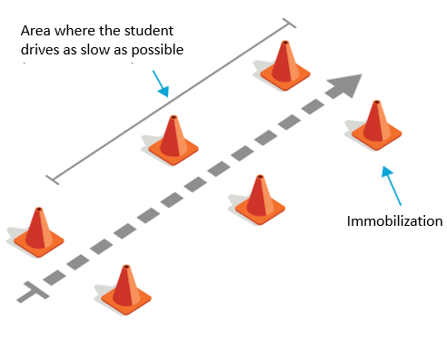

6. GEAR CHANGE AND DOWNSHIFT

Objectives
- Maintain balance.
- Make successive gear changes during acceleration.
- Select appropriate transmission gear for speed.
- Shift the transmission into the appropriate gear when downshifting, especially before stopping.
- Use the front and rear brakes to stop the motorcycle at a specific point.

Implementation
- Demonstrate (by you or by a student)
- Make a gear change and explain the different steps at the same time.
- Conduct a guided practice session
- Have students gradually accelerate and shift into second gear, then slow down to shift into first gear and bring the bike to a stop. Assist students as they perform the exercise and provide feedback on their ability to shift gears.
- Conduct a stand-alone practice session
- Let students do the exercise and observe them so that their learning can be assessed afterwards.
- If space permits, have students do two successive gear changes in order to move into third gear.

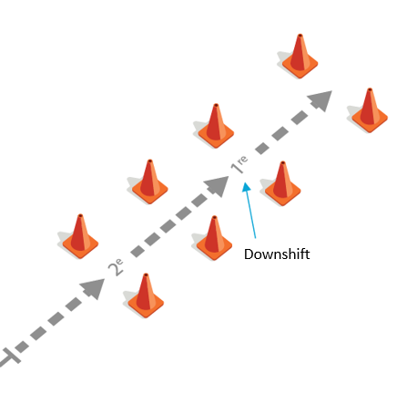

7. Parking

Objectives
- Park safely

Implementation
- Demonstrate (by you or a student)
- Park the motorcycle safely (diagonally with the rear wheel as close to the curb as possible). Explain afterwards the different steps when parking.
- Conduct a stand-alone practice session
- Let students practice parking their motorcycle.

8. Taking a turn

Objectives
- Adopt a safe driving position when making a turn.
- Direct your eyes to the right place when making a turn.
- Counterbalance.
- Maintain balance while making a turn
- Adapt speed.
- Take a sharp turn without being carried into the adjacent lane

Implementation
- Demonstrate (by you or a student)
- Take the turn and explain the different steps.
- Conduct a guided practice session
- Invite students to move around the course one at a time. After a few rounds, or when they are able to move around the course easily, gradually reduce the radius of the circle to make the turn as tight as possible. This will require students to counterbalance the bike to turn. Assist students as they perform the exercise and provide feedback.
- Conduct a stand-alone exercise session
- Let students do the exercise and observe them so that their ability to handle a motorcycle can be assessed later.

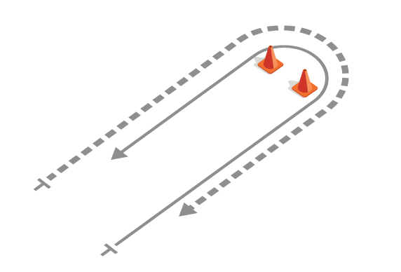
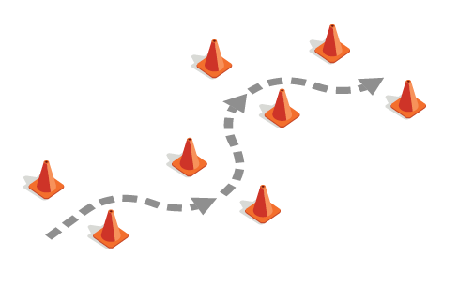
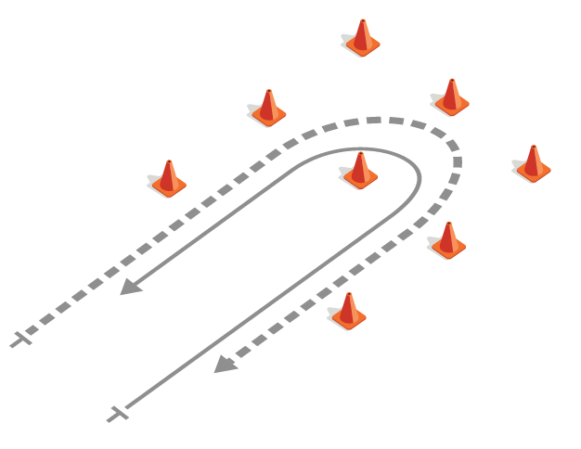

9. EMERGENCY BRAKING IN A STRAIGHT LINE

Objectives
- Adopt a safe driving position when braking.
- Use the brakes in the proper proportion to avoid locking the wheels.
- Shift down to a lower gear so that you can start up again quickly if necessary after braking.
- Keep your balance while braking.

Implementation
- Demonstrate (by you or by a student)
- Do the exercise at a speed of about 30 km/h. Explain afterwards the different steps of the emergency braking.
- Conduct a guided practice session
- Before the exercise, tell the students that they will have to start braking when you lower your arm. Then move to the second-to-last cone on the course to indicate where the students should initiate their braking. Assist students as they perform the exercise and provide feedback on their braking ability.
- Conduct a stand-alone practice session
- Allow students to practice braking and observe them to assess their ability to handle a motorcycle.

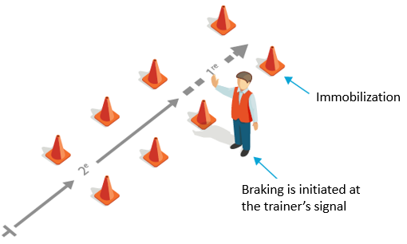

10. OBSTACLE AVOIDANCE

Objectives
- Adopt a safe driving position when avoiding obstacles.
- Control speed during the avoidance maneuver.
- Counter-steer.
- Control the direction of the motorcycle during and after the maneuver.
- Use the brakes in the proper proportion to avoid locking the wheels.
- Shift down to a lower gear so that you can start again quickly if necessary after braking.

Implementation
- Demonstrate (by you or by a student)
- Perform the exercise and explain the different steps in avoiding an obstacle.
- Conduct a guided practice session
- Assist students as they perform the exercise and provide feedback on how they are performing the obstacle avoidance.
- Conduct a stand-alone practice session
- Allow students to practice obstacle avoidance and observe them to assess their ability to maneuver a motorcycle.
- Students should perform obstacle avoidance at low speeds first, then increase speed slightly. It is important that they downshift as they brake.

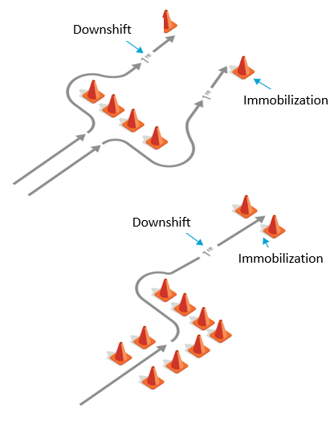
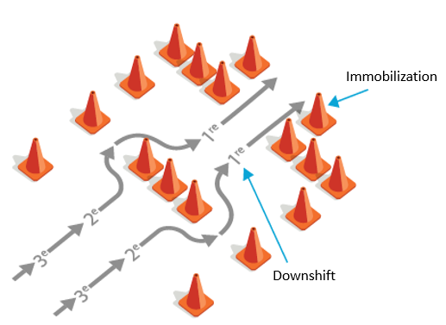

Evaluation
Instructions: Suggest to the student that he/she rate him/herself out of 5 on the following scale, and then rate him/her in turn :
 | Student | Trainer
Protective equipment and mechanical check
Controls, driving position and starting
Vision and gaze direction
Moving and handling a motorcycle
Setting in motion, balance and immobilization
Gear change, downshift
Taking a turn
Parking
Emergency braking in a straight line
Obstacle avoidance

Date : ________________
The student has met the learning objectives and can proceed to the next block of training? Y/N : _____
Trainer's comments and signature : ________________________________________________________________________________________________________________________________________________________________________________________________________________________________________________________________________________________________________________________________________
Student's comments and signature : ________________________________________________________________________________________________________________________________________________________________________________________________________________________________________________________________________________________________________________________________________

