1.2 UNHCR Global Fleet Strategy 2014 – 2018
Global Fleet Management is working to implement the UNHCR fleet Strategy. The Fleet Strategy provides a 5-year work-plan that has the following objectives:
- Improve the efficiency of the UNHCR vehicle fleet;
- Improve road safety for UNHCR personnel and other road users;
- Minimize the environmental impact of UNHCR vehicle operations.
To achieve these objectives the following actions will be undertaken:
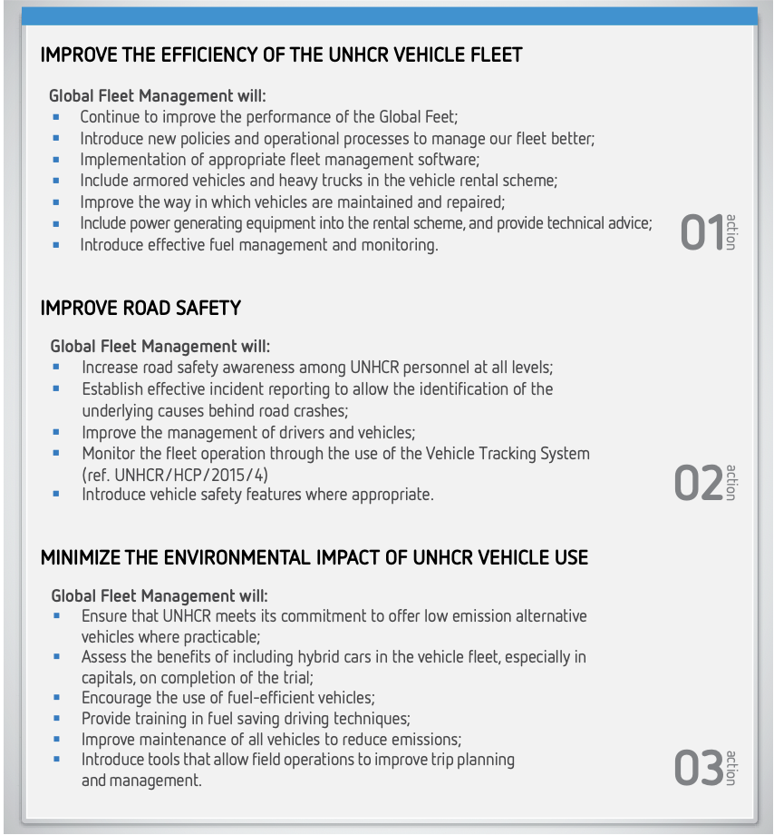

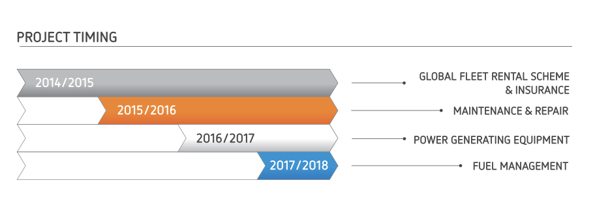

By undertaking these activities between 2014 and 2018 Global Fleet Management will be able to:
- Provide UNHCR with a modern, fit for purpose, and well functioning fleet,
- Reduce both the capital and operating costs of the UNHCR fleet,
- Build fleet management capacity throughout UNHCR,
- Reduce death and injury of UNHCR personnel and other road users due to road traffic accidents,
- Reduce harmful environmental impact from UNHCR fleet operations,
- Enhance asset control and management.

